Customer Shopping Behavior Analysis

1. Project Overview
This project analyzes customer shopping behavior using transactional data from 3,900 purchases across various product categories. The goal is to uncover insights into spending patterns, customer segments, product preferences, and subscription behavior to guide strategic business decisions.

2. Dataset Summary
- Rows: 3,900
- Columns: 18
- Key Features:
- Customer demographics (Age, Gender, Location, Subscription Status)
- Purchase details (Item Purchased, Category, Purchase Amount, Season, Size, Color)
- Shopping behavior (Discount Applied, Promo Code Used, Previous Purchases, Frequency of Purchases, Review Rating, Shipping Type)
- Missing Data: 37 values in the Review Rating column

3. Exploratory Data Analysis using Python
We began with data preparation and cleaning in Python:
- Data Loading: Imported the dataset using pandas.
- Initial Exploration: Used df.info() to check structure and .describe() for summary statistics.
- Missing Data Handling: Checked for null values and imputed missing values in the Review Rating column using the median rating of each product category.
- Column Standardization: Renamed columns to snake_case for better readability and documentation.
- Feature Engineering: Created age_group by binning customer ages into quartiles (Young Adult, Adult, Middle-aged, Senior); created purchase_frequency_days by mapping the Frequency of Purchases field to a numeric day count.
- Data Consistency Check: Verified that discount_applied and promo_code_used were redundant (identical in every row); dropped promo_code_used.
- Database Integration: Connected the Python script to MySQL (via SQLAlchemy + PyMySQL) and loaded the cleaned DataFrame into the database for SQL analysis.

4. Data Analysis using SQL (Business Transactions)
We performed structured analysis in MySQL to answer key business questions:

4.1 Revenue by Gender
Compared total revenue generated by male vs. female customers.
gender | revenue
Female | 75,191
Male | 157,890

4.2 High-Spending Discount Users
Identified customers who used discounts but still spent above the average purchase amount. 839 customers met this criterion; a sample is shown below.
customer_id | purchase_amount
2 | 64
3 | 73
4 | 90
7 | 85
9 | 97
12 | 68
13 | 72
16 | 81
20 | 90
22 | 62
Total rows: 839

4.3 Top 5 Products by Rating
Found the products with the highest average review ratings.
item_purchased | Average Product Rating
Gloves | 3.86
Sandals | 3.84
Boots | 3.82
Hat | 3.80
Skirt | 3.78

4.4 Shipping Type Comparison
Compared average purchase amounts between Standard and Express shipping.
shipping_type | avg_purchase_amount
Standard | 58.46
Express | 60.48

4.5 Subscribers vs. Non-Subscribers
Compared customer count, average spend, and total revenue across subscription status.
subscription_status | total_customers | avg_spend | total_revenue
Yes | 1,053 | 59.49 | 62,645
No | 2,847 | 59.87 | 170,436

4.6 Discount-Dependent Products
Identified the 5 products with the highest percentage of discounted purchases.
item_purchased | discount_rate (%)
Hat | 50.00
Sneakers | 49.66
Coat | 49.07
Sweater | 48.17
Pants | 47.37

4.7 Customer Segmentation
Classified customers into New, Returning, and Loyal segments based on previous purchase count.
customer_segment | Number of Customers
Loyal | 3,116
Returning | 701
New | 83

4.8 Top 3 Products per Category
Listed the most purchased products within each category using a window-function ranking.
item_rank | category | item_purchased | total_orders
1 | Accessories | Jewelry | 171
2 | Accessories | Sunglasses | 161
3 | Accessories | Belt | 161
1 | Clothing | Blouse | 171
2 | Clothing | Pants | 171
3 | Clothing | Shirt | 169
1 | Footwear | Sandals | 160
2 | Footwear | Shoes | 150
3 | Footwear | Sneakers | 145
1 | Outerwear | Jacket | 163
2 | Outerwear | Coat | 161

4.9 Repeat Buyers & Subscriptions
Checked whether customers with more than 5 previous purchases are more likely to subscribe.
subscription_status | repeat_buyers
No | 2,518
Yes | 958

4.10 Revenue by Age Group
Calculated the total revenue contribution of each age group.
age_group | total_revenue
Young Adult | 62,143
Middle-aged | 59,197
Adult | 55,978
Senior | 55,763

5. Dashboard in Power BI
Finally, we built an interactive two-page dashboard in Power BI to present these insights visually, with slicers for category, season, subscription status, and gender.
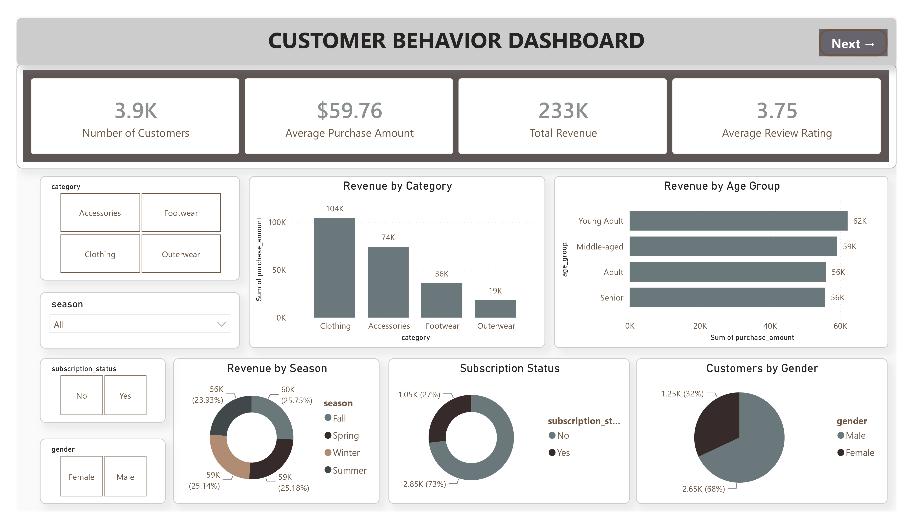
Dashboard — Page 1: KPIs, revenue by category, age group, season, subscription, and gender
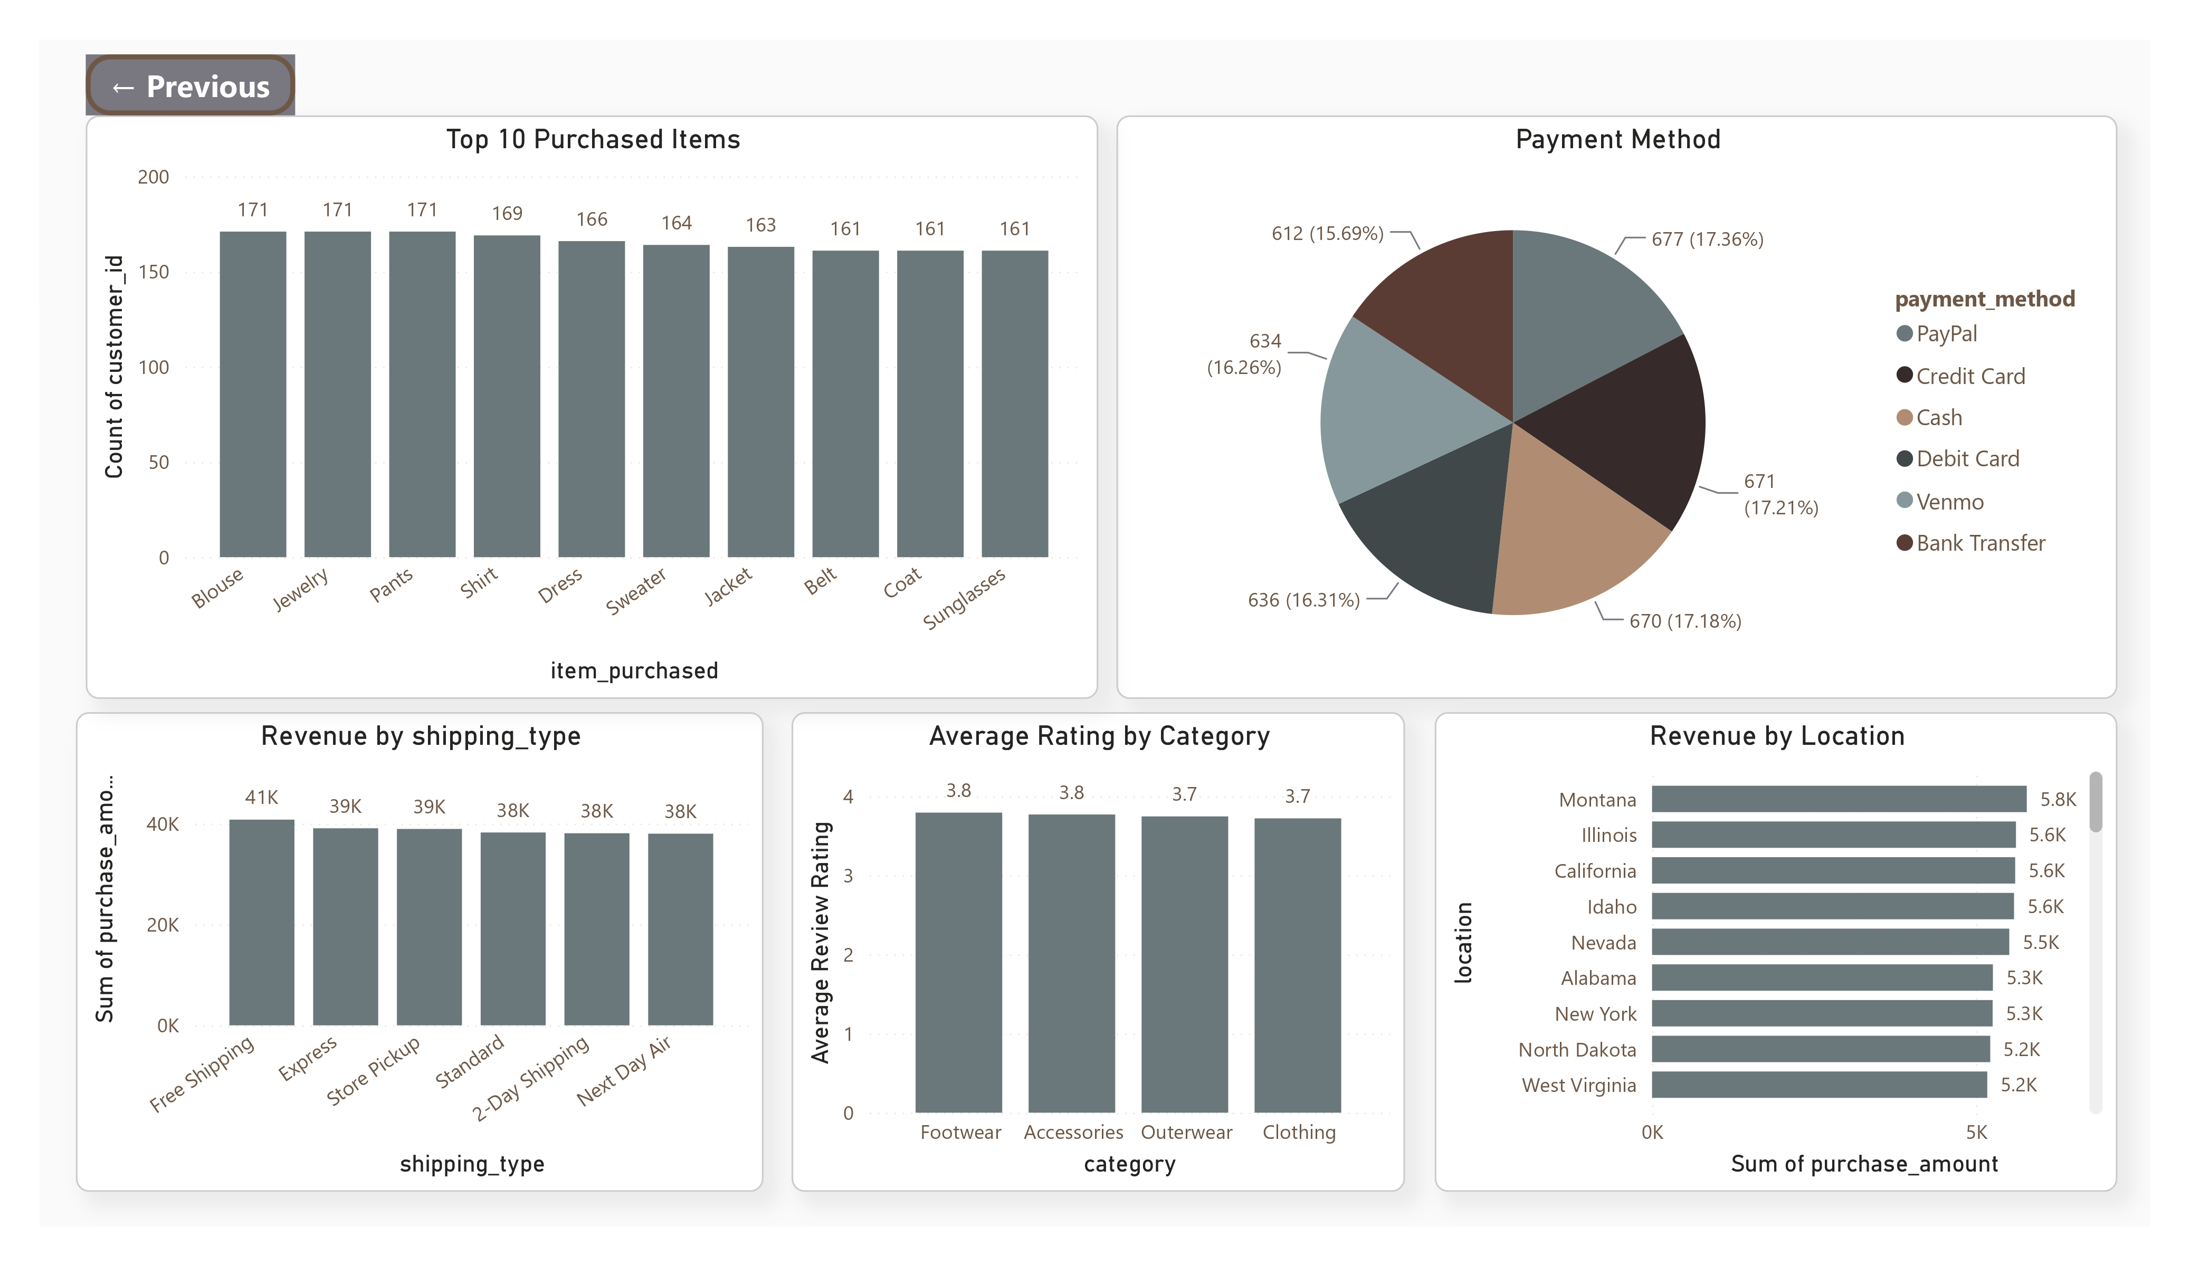
Dashboard — Page 2: top products, payment method, shipping, ratings, and revenue by location

6. Business Recommendations
- Boost Subscriptions – Promote exclusive benefits for subscribers; only 27% of customers (1,053) are currently subscribed, yet they represent a meaningful, stable revenue base worth growing.
- Customer Loyalty Programs – Reward repeat buyers to move the 701 “Returning” customers into the 3,116-strong “Loyal” segment.
- Review Discount Policy – Hat, Sneakers, Coat, Sweater, and Pants rely on discounts for roughly half of their sales; balance further sales boosts against margin control.
- Product Positioning – Highlight top-rated products (Gloves, Sandals, Boots, Hat, Skirt) and top-selling items per category (Jewelry, Blouse/Pants, Sandals, Jacket) in marketing campaigns.
- Targeted Marketing – Focus efforts on the highest-revenue age groups (Young Adult, Middle-aged) and Express-shipping users, who spend more on average ($60.48) than Standard-shipping users ($58.46).

